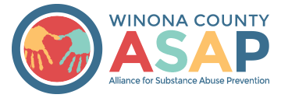

Winona County Alliance for Substance Abuse Prevention & Crime Prevention Committee
October 15, 2018: 2:30 – 4:00 pm at Pleasant Valley Church

ATTENDANCE

Board of Directors:
*Bolded names were present
Attendance: | Board Member: | Proxy: | Sector:
- | Travis Volkman |  | CJCC liaison
Present | Helen Bagshaw |  | Health – Vice-Chair
Present | Karin Sonneman | Rebecca Church | Government
Present | Ron Ganrude | Jeff Mueller | Law Enforcement
- | Linda King | Karla Eppler | Business
- | Mark Anderson | Chai Lee | Schools
Present | Brian Sauter |  | Faith
Present | Molly Dahl |  | Parent
Present | Beth Moe | Brian Voerding | Civic/Volunteer - Chair
Present | Jenna McMillan |  | Substance Abuse Treatment
Present | Darci Roesler | Craig Putz | Youth Serving Organization
Present | Greg Taylor |  | Media
Present | Payton Borchardt |  | Youth
Present | Janneke Sobeck | (non-voting) | Program Director
Present | Phil Huerta | (non-voting) | Program Coordinator

Coalition Members and Guests:
Name: | Organization:
Bridget Klinger | Winona Police Department
Melissa Adolfson | EpiMachine - Evaluator
Heather Dionysius | WSU Student

Consent Agenda
October meeting agenda: Approved
September meeting minutes: Approved

Financial Update
Coordinator provided a brief update on the year end totals for Year 3 of Drug-Free Community funding.
Total spent: $100,175.50
Total in-kind match recorded: $104,840.87
Carryover amount: $9,911.75
See more in the Budget Summary enclosed.

Board and coalition member self-evaluations
Helen Bagshaw reminded the Board and guests to complete the anonymous Coalition Survey as a self-evaluation and to provide the group with feedback for improvement. A summary of results will be provided at a future meeting by our independent evaluator – Melissa from EpiMachine. She will also be scheduling phone conversations with Board members to ask evaluation specific questions after Nov. 1.

Please complete the survey no later than November 9.
Link to access Coalition Survey: https://goo.gl/forms/T6SszR4cX1YifS1V2

Highlights and recommendations from Charlotte’s (Project Officer) site visit
We met all requirements for the funding we have received (Note: there is no option for "exceeds requirements"). Charlotte was very pleased with what we are doing. She did have some technical assistance recommendations:
- Administration and Management: The executive committee will train and work with the coalition leadership to take more responsibility for the development of the action plan, implementation and procedures over the next two-year period.
- Assessment: Coalition members should find additional data from their sectors using out-of-the-box thinking that involves assessing factors that may encourage non-substance use in the community. Potentially an emphasis on higher social capital or increasing positive social norms.
- Capacity Building: Individual sector member contact to review/update CIAs, review communication outreach from representative to other community members in that sector. Solicit information from each rep for each of the 7 strategies for each substance addressed.
- Strategic Planning: Active sector reps. to solicit information from community members for each of the 7 strategies. Reps. should also look for written and unwritten policies within their sector.
- Implementation: All sectors need to determine data sources available pertaining to their sector. Sector members need to communicate well with members of the community they represent.
Discuss/prioritize local conditions
Melissa [evaluator] facilitated a discussion about 20 possible local conditions, hanging on the wall around the room, to gauge existing movement and community readiness to address each. Those in attendance then voted with small colored sticky dots to prioritize the local conditions and identify seven we want to address. Red dots were worth 3 points, and Green dots were worth 1 point.
Images of the activity results are included below.

The 7 local conditions that were prioritized are:
Took alcohol from home
Got alcohol from parents
Got alcohol from parties
Perceive low risk of harm from drinking
Get marijuana from youth adults ages 18-25
Perceive lost risk of harm from marijuana use
Easy access to e-cigarettes

Areas the group thinks we need more data collection include:
E-cigarettes
Place of last drink (bars, homes)
School policies review

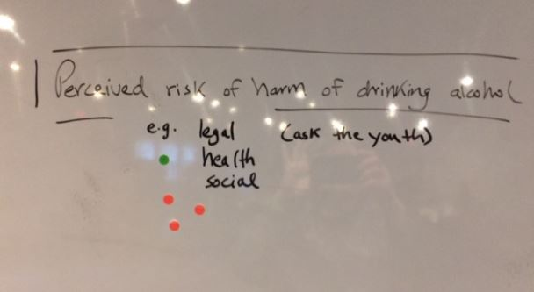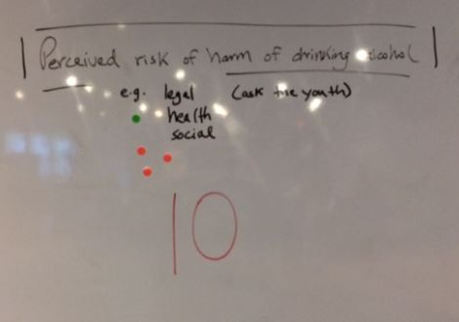

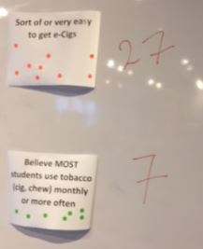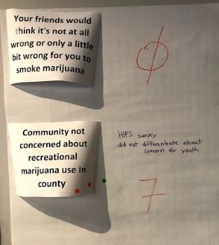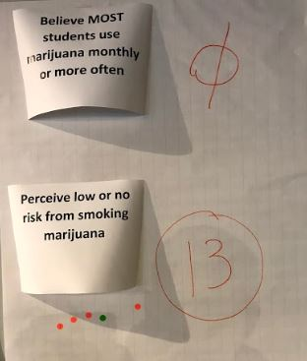

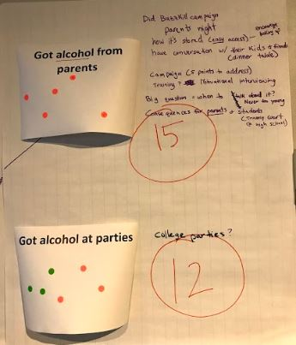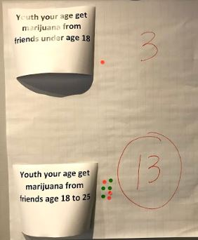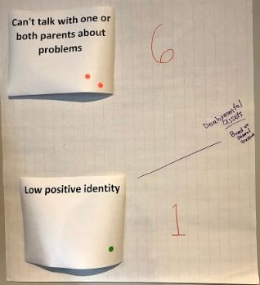

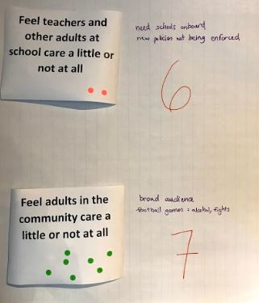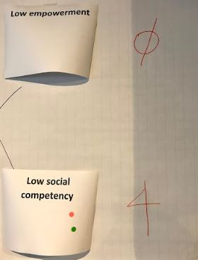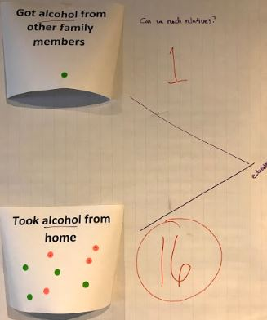

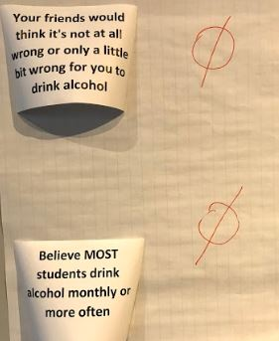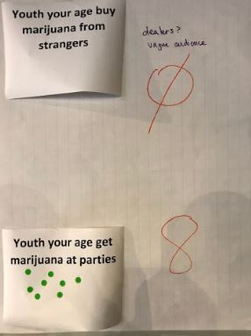

Next Meeting: November 19, 2018 at 2:30pm at Pleasant Valley Church
Respectfully submitted,
Phil Huerta, Program Coordinator
